# Testing Scenarios Rev 1

# RM- ENG ~ 1 min / ENG-ENG (Just for understanding)

## Output was read out loud after a lot of delay not simultaneously.

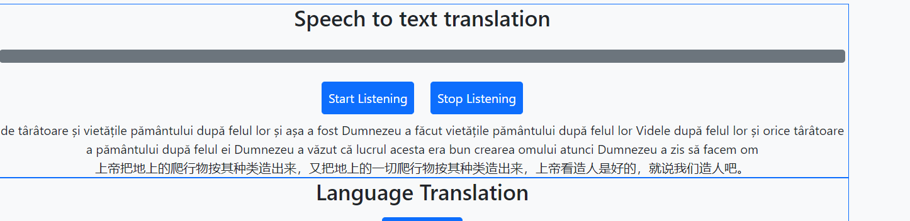

## Same for rm- Chinese ENG-ENG (Just for understanding)

# RM to EN: 30 sec Pause between two sets of lines.

## Some pause

# RM-ENG 30 sec continuous input

## After 30 sec of pause in input

## After 1min 45 sec pause

# AFTER LONG Inactivity (3-4min) on the webpage ( Stop Listening was pressed before inactivity)

Steps:

1. Press Start Listening (Languages are already selected from last run)

## Changing output language in between of the run

## EN-RM

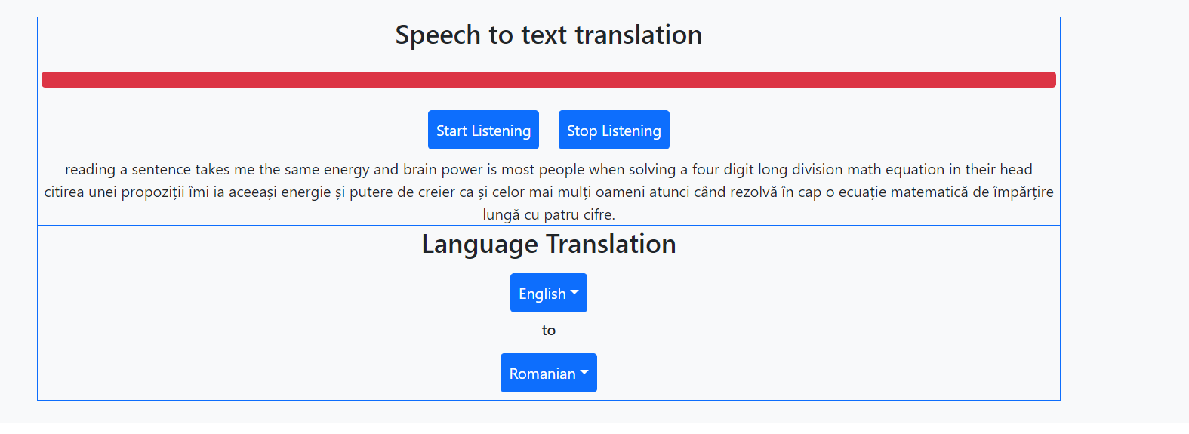

## EN-CH

## So changing the output language in between the run does work.

Multiple inputs :

* Inputs does get mixed up but again these are shortcomings of the Microphone (Noise cancelling capacity) , but multiples source input does affect the translation.
* Assuming Microphone with Noise cancellation is in place and the church application involves only one individual addressing the audience, the issue of multiple input can be ruled out.

## Observations:

1. Translation appears or happens only after a noticeable pause is observed in the input.
2. As far as the input language is English the delay observed in translation is less than when the input language is not English (Tested one is Romanian)
3. Multiple cycles of “Start-Listening” then “Stop Listening” still works well.
4. Multiple Output Language changes in between the run also works (with delay).
5. Pause in speech till around 1.45 min is acceptable.
6. After long Inactivity (After stop Listening)-🡪 The next run also works fine (with the previously selected languages options intact)

Note:

1. Assuming once in the beginning if the microphone permission is given, the permission is not revoked in between and is never asked again in between the translation process.
2. System Behavior: for my system microphone permission is asked continuously at random intervals, if that means calling the” Start Listening” Function again, then the above-mentioned observations should be discarded.
3. Sometimes the translated output is not readout. (Random occurrence) might be system issue. But once the speaker stops, even reloading the page does not get the speaker back.
4. Microphone permission is being asked multiple times at random interval.
5. These are all system specific dependencies.

Points to Change :

1. Give some alert for wrong message while login
2. A screenshot of a computer

   Description automatically generated
3. With langiage options change , should the text box get refreshed or should it continue .
4. Thoughts on adding a logout option?
5. A screenshot of a computer

   Description automatically generated
6. A screenshot of a computer

   Description automatically generated

